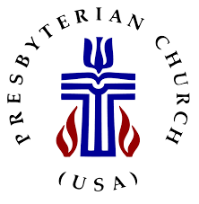
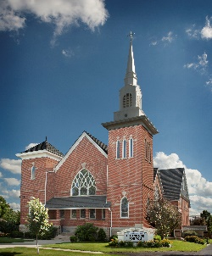
Belle Center United Presbyterian Church
202 Walnut ST, P O Box 186
Belle Center, OH 43310
(937)464-2695
bellecenterupc@live.com

Monday, March 16, 2020

Friends in Christ,

Grace and Peace to you, in the name of our Lord Jesus Christ. A few weeks ago, I shared from Psalm 121, I lift up my eyes to the hills-- from where will my help come? My help comes from the LORD, who made heaven and earth. Be assured that indeed, our help comes from the Lord. But at this difficult time, we need to be supporting one another – being the eyes and ears of Jesus – if not the hands and feet.
In light of the quickly changing restrictions on public gatherings due to the coronavirus (the pandemic announced by the World Health Organization), I write today to share some decisions that the session made following worship yesterday. After prayerful consideration and looking at the advice of our Presbytery, we will suspend worship for the next three Sundays (this coincides with the school closings). Our tentative plan is to meet on Easter Sunday but that will be determined during Holy Week. The Maundy Thursday agape meal will be cancelled. We will determine closer to the time if it is safe to gather for Good Friday worship. All meetings, choir, and Bible studies are also cancelled. If meetings are needed, they will be done remotely using Zoom or conference calling. Announcements will be made on the church website (bellecenterupc.com). We will also use One Call for updates. If you would like to be added to the One Call group, please call the office and leave a message (we will be checking them).

Social distancing is one way we can be good neighbors to those who may be compromised. We may not show symptoms but could carry the virus to those who are more susceptible. I know this is difficult and we want to continue to be in touch – but not in person. With that in mind, the deacons and elders each took names of members to contact on a weekly basis. I have attached the names and numbers of our elders and deacons if you need to reach them. Be expecting a call from someone who loves you! I will also be trying to share some sort of devotions and a message on Sunday by way of email, the website and possibly Facebook.

Session is asking that no one enter the building during this time. We are trying to contain any possible spread of germs. Jodi will be working but please respect her request for social distancing. I will be working from the manse. If you must go to the church, please contact Jodi or me before you do – the church may be alarmed, even during the day. If you can, please consider continuing to support the church during this time with your tithes and offerings. You can mail them to the church at 202 Walnut St. PO Box 186 Belle Center, OH 43310.

If you are in need of assistance, you can reach me by calling or texting 419-297-8539 or email me at lynnsbellecenter@gmail.com. Please feel free to contact me even if you are just bored and want to chat. Nursing Care facilities and hospitals will not allow visits by family or pastors at this time. Cards would be welcomed! Please stay in touch with one another and with our home centered members. Remember to love one another – you are so good at that!

Grace and Peace,

Pastor Lynn

Rev. Lynette (Lynn) Bova
Transitional/Interim Pastor
Belle Center United Presbyterian Church
202 E. Walnut St.
PO Box 186
Belle Center, OH 43310
937-464-2695 (church)
419-297-8539 (cell)

